**Kalinga Institute of Industrial Technology**

**CN LAB-4.8.21**

NAME: Ankit Raj

ROLL NO: 1906534

**1.TCP SOCKET CLIENT WILL SEND AN INTEGER ARRAY, AND RECEIVE SORTED ARRAY SERVER.**

Server.c

**#include<stdio.h>**

**#include<sys/types.h>**

**#include<sys/socket.h>**

**#include<netinet/in.h>**

**#include<arpa/inet.h>**

**#include<fcntl.h>**

**#include<string.h>**

**#include<unistd.h>**

**int main()**

**{**

**int sockfd_534,fd1_534, length_534,i_534,buf_534[100],n_534;**

**struct sockaddr_in sa_addr_534,cl_addr_534;**

**sockfd_534=socket(AF_INET,SOCK_STREAM,0);**

**sa_addr_534.sin_family=AF_INET;**

**sa_addr_534.sin_addr.s_addr=INADDR_ANY;**

**sa_addr_534.sin_port=htons(6000);**

**i_534=bind(sockfd_534,(struct sockaddr *)&sa_addr_534,sizeof(sa_addr_534));**

**printf("test %d%d\n",sockfd_534,i_534);**

**listen(sockfd_534,5);**

**length_534=sizeof(cl_addr_534);**

**fd1_534=accept(sockfd_534, (struct sockaddr *) &cl_addr_534,&length_534);**

**for(i_534=0; i_534 < 100; i_534++) buf_534[i_534] = 0;**

**recv(fd1_534, buf_534, 100, 0);**

**recv(fd1_534, &n_534 , sizeof(n_534), 0);**

**for(int i_534=0; i_534<n_534-1; i_534++)**

**{**

**for(int j_534=0; j_534<n_534-i_534-1; j_534++)**

**{**

**if(buf_534[j_534]>buf_534[j_534+1])**

**{**

**int temp_534=buf_534[j_534];**

**buf_534[j_534]=buf_534[j_534+1];**

**buf_534[j_534+1]=temp_534;**

**}**

**}**

**}**

**send(fd1_534, buf_534, 100, 0);**

**close(fd1_534);**

**}**

Client.c

**#include<stdio.h>**

**#include<sys/types.h>**

**#include<sys/socket.h>**

**#include<netinet/in.h>**

**#include<arpa/inet.h>**

**#include<fcntl.h>**

**#include<string.h>**

**#include<unistd.h>**

**int main()**

**{**

**int i_534,sockfd_534,buf_534[100],n_534;**

**struct sockaddr_in sa_addr_534;**

**sockfd_534=socket(AF_INET,SOCK_STREAM,0);**

**sa_addr_534.sin_family=AF_INET;**

**sa_addr_534.sin_addr.s_addr=inet_addr("127.0.0.1"); *//Loop back IP address***

**sa_addr_534.sin_port=htons(6000);**

**memset(sa_addr_534.sin_zero, '\0', sizeof sa_addr_534.sin_zero);**

**i_534=connect(sockfd_534,(struct sockaddr *)&sa_addr_534,sizeof(sa_addr_534));**

**printf("utkarsh , Enter the size of the array\n");**

**scanf("%d",&n_534);**

**printf("utkarsh , Enter the input into the array\n");**

**for(int i_534=0; i_534<n_534; i_534++)**

**{**

**scanf("%d",&buf_534[i_534]);**

**}**

**send(sockfd_534, buf_534, 100, 0);**

**send(sockfd_534, &n_534, sizeof(n_534),0);**

**recv(sockfd_534, buf_534, 100, 0);**

**for(int i_534=0; i_534<n_534; i_534++)**

**{**

**printf("%d ",buf_534[i_534]);**

**}**

**printf("\n");**

**close(sockfd_534);**

**}**

**OUTPUT:**

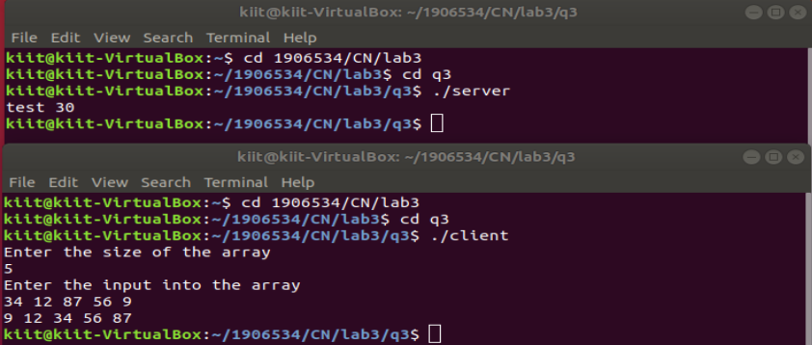

1. **TCP SOCKET SERVER DEAL WITH TWO CLIENT TO EXCHANGE NUMBER**

Server.c

**#include<stdio.h>**

**#include<sys/types.h>**

**#include<sys/socket.h>**

**#include<netinet/in.h>**

**#include<arpa/inet.h>**

**#include<fcntl.h>**

**#include<string.h>**

**#include<unistd.h>**

**int main()**

**{**

**int sockfd_534,sockfd1_534,fd1_534,fd2_534, length_534,length1_534,i_534,j_534;**

**int buf_534,buf1_534;**

**struct sockaddr_in sa_addr1_534,cl_addr1_534;**

**struct sockaddr_in sa_addr_534,cl_addr_534;**

**sockfd_534=socket(AF_INET,SOCK_STREAM,0);**

**sockfd1_534=socket(AF_INET,SOCK_STREAM,0);**

**sa_addr_534.sin_family=AF_INET;**

**sa_addr1_534.sin_family=AF_INET;**

**sa_addr_534.sin_addr.s_addr=INADDR_ANY;**

**sa_addr1_534.sin_addr.s_addr=INADDR_ANY;**

**sa_addr_534.sin_port=htons(3000);**

**sa_addr1_534.sin_port=htons(2995);**

**memset(sa_addr_534.sin_zero, '\0', sizeof sa_addr_534.sin_zero);**

**memset(sa_addr1_534.sin_zero, '\0', sizeof sa_addr1_534.sin_zero);**

**i_534=bind(sockfd_534,(struct sockaddr *)&sa_addr_534,sizeof(sa_addr_534));**

**j_534=bind(sockfd1_534,(struct sockaddr *)&sa_addr1_534,sizeof(sa_addr1_534));**

**printf("test %d%d\n",sockfd_534,i_534);**

**printf("test %d%d\n",sockfd1_534,j_534);**

**listen(sockfd_534,5);**

**listen(sockfd1_534,5);**

**length_534=sizeof(cl_addr_534);**

**length_534=sizeof(cl_addr1_534);**

**fd1_534=accept(sockfd_534, (struct sockaddr *) &cl_addr_534,&length_534);**

**fd2_534=accept(sockfd1_534, (struct sockaddr *) &cl_addr1_534,&length1_534);**

**recv(fd1_534, &buf_534, sizeof(buf_534),0);**

**printf("%d",buf_534);**

**recv(fd2_534, &buf1_534,sizeof(buf1_534),0);**

**printf("%d",buf1_534);**

**send(fd1_534, &buf1_534, sizeof(buf_534),0);**

**send(fd2_534, &buf_534,sizeof(buf1_534),0);**

**close(fd1_534);**

**close(fd2_534);**

**}**

Client1.c

**#include<stdio.h>**

**#include<sys/types.h>**

**#include<sys/socket.h>**

**#include<netinet/in.h>**

**#include<arpa/inet.h>**

**#include<fcntl.h>**

**#include<string.h>**

**#include<unistd.h>**

**int main()**

**{**

**int i_534,sockfd_534;**

**int buf_534;**

**struct sockaddr_in sa_addr_534;**

**sockfd_534=socket(AF_INET,SOCK_STREAM,0);**

**sa_addr_534.sin_family=AF_INET;**

**sa_addr_534.sin_addr.s_addr=inet_addr("127.0.0.1");**

**sa_addr_534.sin_port=htons(2995);**

**memset(sa_addr_534.sin_zero, '\0', sizeof sa_addr_534.sin_zero);**

**i_534=connect(sockfd_534,(struct sockaddr *)&sa_addr_534,sizeof(sa_addr_534));**

**printf("Enter the number\n");**

**scanf("%d",&buf_534);**

**send(sockfd_534, &buf_534, sizeof(buf_534), 0);**

**recv(sockfd_534, &buf_534, sizeof(buf_534), 0);**

**printf("%d\n", buf_534);**

**close(sockfd_534);**

**}**

Client2.c

**#include<stdio.h>**

**#include<sys/types.h>**

**#include<sys/socket.h>**

**#include<netinet/in.h>**

**#include<arpa/inet.h>**

**#include<fcntl.h>**

**#include<string.h>**

**#include<unistd.h>**

**int main()**

**{**

**int i_534,sockfd_534;**

**int buf_534;**

**struct sockaddr_in sa_addr_534;**

**sockfd_534=socket(AF_INET,SOCK_STREAM,0);**

**sa_addr_534.sin_family=AF_INET;**

**sa_addr_534.sin_addr.s_addr=inet_addr("127.0.0.1");**

**sa_addr_534.sin_port=htons(3000);**

**memset(sa_addr_534.sin_zero, '\0', sizeof sa_addr_534.sin_zero);**

**i_534=connect(sockfd_534,(struct sockaddr *)&sa_addr_534,sizeof(sa_addr_534));**

**printf("Enter the number\n");**

**scanf("%d",&buf_534);**

**send(sockfd_534, &buf_534, sizeof(buf_534), 0);**

**recv(sockfd_534, &buf_534, sizeof(buf_534), 0);**

**printf("%d\n", buf_534);**

**close(sockfd_534);**

**}**

**OUTPUT:**

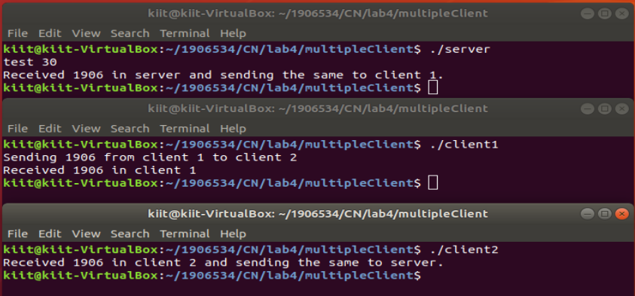

1. **TCP SOCKET USING STRUCTURE SEND THE DETAILS TO THE CLIENT, AFTER RECEIVING ROLL NUMBER**

Server.c

**#include <arpa/inet.h>**

**#include <netinet/in.h>**

**#include <stdio.h>**

**#include <string.h>**

**#include <sys/socket.h>**

**#include <sys/stat.h>**

**#include<unistd.h>**

**#include <sys/types.h>**

**struct student**

**{**

**int roll;**

**char name[50];**

**int marks;**

**};**

**int main()**

**{**

**struct sockaddr_in client, server;**

**int s, n, sock,flag_534=0;**

**int b1_534;**

**struct student a[2];**

**a[0].roll=534;**

**strcpy(a[0].name,"Ankit");**

**a[0].marks=100;**

**a[1].roll=535;**

**strcpy(a[1].name,"Raj");**

**a[1].marks=95;**

**s = socket(AF_INET, SOCK_STREAM, 0);**

**server.sin_family = AF_INET;**

**server.sin_port = 2000;**

**server.sin_addr.s_addr = inet_addr("127.0.0.1");**

**bind(s, (struct sockaddr*)&server, sizeof server);**

**listen(s, 1);**

**n = sizeof client;**

**sock = accept(s, (struct sockaddr*)&client, &n);**

**recv(sock, &b1_534, sizeof(b1_534), 0);**

**int k=0,i=0;**

**for(;i<2;i++)**

**{**

**if(a[i].roll==b1_534)**

**{**

**k=1;**

**break;**

**}**

**}**

**if(k==1)**

**printf("%s %d",a[i].name,a[i].marks);**

**else**

**printf("\nNot found");**

**close(sock);**

**close(s);**

**}**

Client.c

**#include <arpa/inet.h>**

**#include <netinet/in.h>**

**#include <stdio.h>**

**#include <string.h>**

**#include <sys/socket.h>**

**#include<unistd.h>**

**#include <sys/stat.h>**

**#include <sys/types.h>**

**int main()**

**{**

**struct sockaddr_in client;**

**int s, flag_534;**

**int buffer_534;**

**s = socket(AF_INET, SOCK_STREAM, 0);**

**client.sin_family = AF_INET;**

**client.sin_port = 2000;**

**client.sin_addr.s_addr = inet_addr("127.0.0.1");**

**connect(s, (struct sockaddr*)&client, sizeof client);**

**printf("\nEnter a roll no\t");**

**scanf("%d", &buffer_534);**

**send(s, &buffer_534, sizeof(buffer_534), 0);**

**close(s);**

**}**

**OUTPUT:**

